Case 5-Asia-China-Roof Tile-Hexgram-Dai Qing

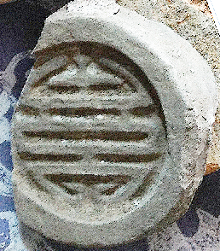

Water  (above) and Fire  (below) as hexagrams conjoined in one roof tile that were combined as a composite apotropaic symbol to invoke water to descend and extinguish fire in the building on which it was placed.



The opposition of water and fire in the Yin-Yang hexagrams